**AUTOMATIC NUMBER PLATE RECOGNITION USING PYTHON-OPENCV AND TENSORFLOW**

**Ankit Jambhulkar*1,Himanshu Patil*2,Aniket Patil*3,Prashant Govardhan*4**

*1 [ankitjambhulkar0407@gmail.com](mailto:ankitjambhulkar0407@gmail.com) , UG Scholar, Priyadarshini College of Engineering , Department of Computer Science & Engineering

Nagpur, Maharashtra, India

*2[hpatil882000@gmail.com](mailto:hpatil882000@gmail.com) , UG Scholar, Priyadarshini College of Engineering , Departmentof Computer Science & Engineering, Nagpur, Maharashtra. India

*3[aniketpatilcool@gmail.com](mailto:aniketpatilcool@gmail.com) , UG scholar, , Priyadarshini College of Engineering , Department of computer Science &Engineering, Nagpur, Maharashtra, India

*4[er.phgovardhan@gmail.com](mailto:er.phgovardhan@gmail.com) , Professor, Priyadarshini College of Engineering , Department of Computer Science & Engineering, Nagpur, Maharashtra, India

**ABSTRACT**

Object identification and image processing are two areas of research that overlap. Various notable works in the sector of transportation have been completed in order to provide a safe and legal traffic environment. A precise and fast vehicle number plate recognition system is a traffic management solution that leads to better regulations. This research is based on optical character recognition (OCR), which employs advanced approaches to get optimal results. A full-fledged number plate recognition technique is proposed, with improved accuracy over the existing system. The entire system can be installed as a traffic-related legal and security solution. The Automatic Number Plate Recognition (ANPR) technology combines machine learning, image processing, and pattern recognition into one system. Optical character recognition (OCR) is a machine learning and computer vision method that plays a major part in automatic number plate recognition. It is one of the most important aspects of research in machine learning and computer vision.

**Keywords:** **:** Automatic Number Plate Recognition, number plate extraction, character segmentation, character recognition, license plate detection.

1. **INTRODUCTION**

Every country has its own system for creating and assigning number plates to its cars. Various government departments then use this licence number plate for their routine administrative tasks, such as traffic police tracking those who break traffic regulations, identifying stolen automobiles, toll collecting, and parking allotment management, and so on. Every motor vehicle in India is allocated a unique number. The Regional Transport Office at the district level assigns these numbers to the vehicles (RTO). License plates must be shown on both the front and back of the vehicle in India. On the other hand, given to their high level of intelligence, these plates are generally easy to read for humans. It becomes exceedingly difficult for computers to perform the same activity. Many characteristics, such as illumination, blur, background colour, foreground colour, and so on, will cause issues. In addition, License Plate Recognition (LPR) is challenging in India because traffic rules are rarely followed and number plate standards are not consistently adhered to. Each adopts a different style, resulting in variations in parameters such as number plate size and characters, number plate location, type of font used, background (white background with black letters for non-commercial vehicles and white background with yellow letters for commercial vehicles), unwanted pictures, and so on. This complicates the task of locating licence plates. The major goal of this suggested system is to develop an effective approach for recognising licence plates and extracting text from them under Indian settings. This procedure is done on both vehicle and motorcycle licence plates. Figure 1 depicts a typical Indian car licence plate with the meaning of each character (1. State Code, 2. District Code, 3. Type of Vehicle (car, two-wheeler, commercial, etc.) 4. Actual Registration Number).



**Figure . Format of Licence Plate for Car**

**LITERATURE SURVEY**

1. S Shastry et al. proposed the I system, whose goal is to provide a high-speed, simple, font- and size-independent OCR system that uses a distinct segment extraction technique. This algorithm can be used with a variety of fonts. Artificial intelligence is used in this algorithm [1].
2. This paper offers an overview of the literature on English OCR procedures. The use of an English OCR system is required to transform a large number of published English books into editable computer text files. Recent study in this field has resulted in the development of several novel approaches for dealing with the complexities of English writing style. These algorithms have not yet been tested for the entire English alphabet. As a result, a system that can handle all classes of English text and identify characters within these classes is necessary. [2].
3. The total recognition process of vehicle number plate recognition can be divided into four steps [1], the first of which is to collect full automobile photos or videos with the camera and model camera parameters such as camera resolutions, sutter speed, and lighting. The second stage involves using plate border features, colour features, the presence of characters features, and various edge detections to determine the car plate region in an image or video. Character segmentation based on colour combination and character position is the third stage. The final step is to use template matching to extract character recognition[3].
4. Automatic Number Plate Recognition (ANPR) is an image-processing technology and a growing topic of research that recognises automobiles by their licence plates by extracting the information from the vehicle's image or a sequence of photographs without the need for direct human participation. Preprocessing, number plate extraction, character segmentation, and character identification are the four processes of ANPR. Using morphological procedures, thresholding, Sobel vertical edge detection, and connected component analysis, this work proposes an effective method for extracting number plates from preprocessed vehicle input images. Preprocessing of the input image begins with an iterative bilateral filter and adaptive histogram equalization[4].
5. The most fascinating and difficult study area in recent years has been licence number plate recognition. The number plate recognition system (NPRS) is useful for a variety of applications, including border crossing vehicles, highway toll collecting, traffic management, and parking management at various sites. In this research, we present a technique for detecting number plates in a variety of fonts, with a focus on INDIA. Character segmentation, optical character recognition (OCR), and template matching using MATLAB are the three steps in the detection procedure. We can correctly detect number plates with the least amount of time and approximation by employing this[5].
6. Optical character recognition is a pattern recognition programme that recognises and detects optical characters without the need for human participation. Corners, ends, and bifurcations are three geometric entities that can be utilised to distinguish between characters. We offer a method for recognising visual characters based on basic geometric properties in this work. To extract features from a thinned character, the method uses a crossing number method. Number of corners, ends, and bifurcations make up the feature vector for each character. A basic rule-based strategy is used in the categorization stage to recognise a character. The proposed system is put to the test with different samples for each character, with the results proving the algorithm's validity[6].
7. Automatic license plate recogniti on is a Computer Vision technique which is able to re number . This system is useful in many field likes parking lots, private and p ublic cognize a license plate entrances, theft control. In this paper we d esigned such a system. First we capture the image from camera then load into system after that we used OpenCV library tools . Then we make the training set of different of these training set we extracted the character from images[7].
8. It can be tough to detect a car owner who breaks traffic laws and drives too quickly at times. As a result, it is impossible to apprehend and penalise such individuals since traffic officers may be unable to extract a car number from a moving vehicle due to the vehicle's speed. As a result, one of the answers to this challenge is to design an Automatic Number Plate Recognition (ANPR) system. There are a plethora of ANPR systems on the market today. These systems use many approaches, but it is still a difficult process because factors like as vehicle speed, non-uniform vehicle number plates, language of vehicle number, and changing lighting conditions can all have a significant impact on total recognition[11].
9. **PROPOSED SYSTEM**

The transformation of data from video cameras into a new dimension is an attempt to give computers vision and machine learning the ability to learn activities performed by computers. Many image processing functions are offered by the Open cv library, which is compatible with all operating systems. It primarily focuses on real-time image processing for vehicle number plate recognition.

**INPUT/CAPTURE IMAGE**

A high-resolution photographic camera is used to capture the image of the vehicle ( preferably). An infrared (IR) camera is a superior option. With respect to the licence plates, the camera can be rolled and pitched. The skew affects character recognition in most cases. Because of the camera's obliqueness, readable text can get distorted. The success ratio of the system will improve if a better camera with more definition and resolution is used.

**READING AND PRE-PROCESSING**

The second stage is picture pre-processing, which is critical since it seeks to properly prepare the image so that the next phases may be completed successfully. Greyscale images are commonly utilised in image processing because they are more straightforward than colour images. Aside from that, photos typically include some unwanted noise that needs to be removed. Furthermore, for this application, where number plates are the focus, it is useful to emphasise key elements that distinguish number plates inside the image so that they may be spotted more readily later. This means that image processing techniques must be employed to highlight the vertical lines in the image, making the subsequent location of the number plate in the image easier.

**TENSOR FLOW OBJECT DETECTION**

TensorFlow Object Identification API is an open-source framework built on top of TensorFlow that makes building, training, and deploying object detection models simple.

* Model Zoo, a collection of pre-trained models trained on diverse datasets such as the
* COCO (Common Objects in Context) dataset
* the KITTI dataset
* and the Open Images Dataset

is already available in their framework.

These models have distinct architectures and thus yield varying accuracies, however there is a trade-off between execution speed and bounding box placement precision.

TensorFlow is the most popular software library right now. TensorFlow is popular because of various real-world deep learning applications. TensorFlow is an open-source deep learning and machine learning library that has applications in text-based applications, picture identification, voice search, and many other areas. TensorFlow is used for image identification in DeepFace, Facebook's image recognition technology. Apple's Siri uses it for voice recognition. TensorFlow is used in almost every Google app you use to improve your experience.

**OCR AND PYTESSERACT**

Optical Character Recognition (OCR) is the process of detecting text information on photographs and converting it to encoded text that a computer can interpret. To detect the characters in a text image, the image is scanned and examined. The character is transformed to machine-encoded text after being identified. The image is scanned first, then the text and graphics elements are converted to a bitmap, which is a matrix of black and white dots. The image is then pre-processed to improve the procedure' accuracy by adjusting the brightness and contrast. The image is now divided into zones, which aid start the extraction process by identifying areas of focus like where the images or text are located. The text-containing sections can now be further broken down into lines, words, and characters, and the software can now match the characters using multiple detection techniques and comparison. The text in the image we're shown is the end outcome.

In a nutshell, OCR is a procedure that entails multiple sub-processes in order to perform as precisely as possible. The following subprocesses are included:

• Image preprocessing

• Text localization

• Character segmentation

• Character recognition

• Post processing



**Fig. Data Flow Diagram**

The sub-processes in the above list can vary, but these are the general steps required to approach automatic character recognition. The fundamental goal of OCR software is to recognise and capture all unique words in various languages from written text characters. Python-tesseract is a python-based optical character recognition (OCR) programme. It will recognise and "read" text contained in photos, in other words. Tesseract-OCR Engine from Google is wrapped in Python-tesseract. It can read any image types supported by the Pillow and Leptonica imaging libraries, including jpeg, png, gif, bmp, tiff, and others, making it usable as a standalone tesseract invocation script. Python-tesseract will also print the recognised text rather than writing it to a file if used as a script.

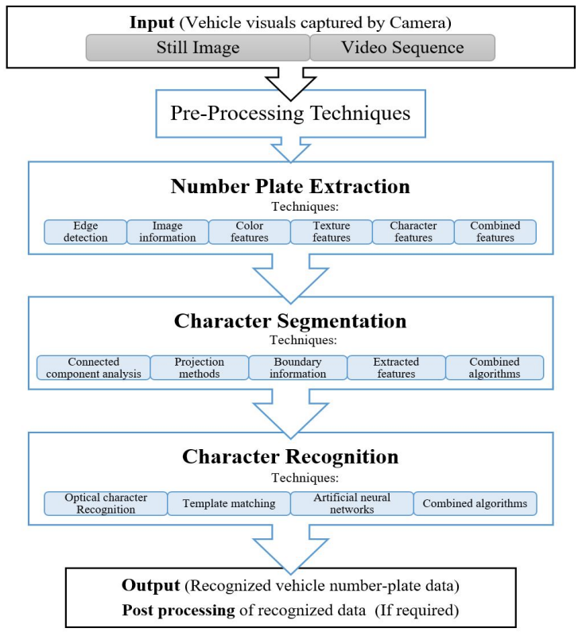

**Fig. Flow Chart for Character Recognition**

1. **RESULTS AND DISCUSSION**

The devised technology initially detects the car before taking a picture of it. The image segmentation in an image is used to retrieve the vehicle number plate region. Character recognition is done using an optical character recognition approach.

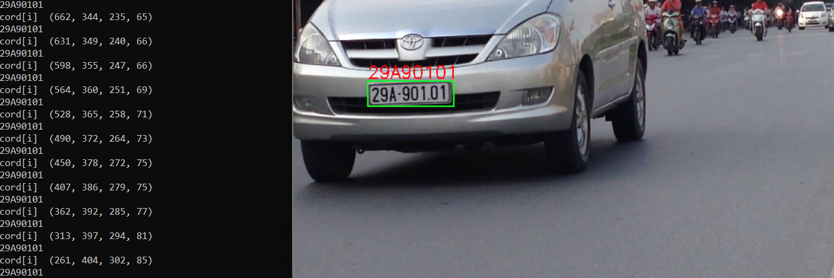

**Img. Displayed Result**

1. **CONCLUSION**

This study presents a practical method for extracting number plates. The proposed solution was created with real-time Indian car number plates in mind, although it also works with foreign number plates. This extraction method works well for images with poor resolution, noise, and low contrast.

**ACKNOWLEDGEMENTS**

The first three authors are grateful to the authorities and department of computer science and engineering of Priyadarshini College of Engineering, Nagpur (Maharashtra, India). The authors are also thankful to Prof. Prashant Govardhan (Project guide) who have been a constant source of inspiration and also took keen interest in each and every step of the project development.

1. **REFERENCES**
2. S. Shastry, Gunasheela G, T Dutt, Vinay D S and SR Rupanagudi - A novel algorithm for Optical Character Recognition (OCR), IEEE 2013.
3. Sukhpreet Singh Optical Character Recognition Techniques: A Survey, Journal of Emerging Trends in Computing and Information Sciences, Vol. 4, No. 6 June 2013.
4. T. Naito, T. Tsukada, K. Yamada, K. Kozuka, and S. Yamamoto, Robust license plate recognition method for passing vehicles under outside environment, Trans. Veh. Technol., vol. 49, no. 6, pp. 23092319, Nov. 2000.
5. Sarbjit Kaur, Sukhvir Kaur “An Efficient Approach for Number Plate Extraction from Vehicles Image under Image Processing”,International Journal of Computer Science and Information Technologies, Vol.5 (3) , 2014, 2954-2959.
6. Mr A. N. Shah, Ms A. S. Gaikwad. “ A Review-Recognition of License Number Plate using Character Segmentation and OCR with Template Matching “, International Journal of Advanced Research in Computer and Communication Engineering,Vol. 5, Issue 2, February 2016.
7. M. Usman Akram, Zabeel Bashir, Anam Tariq and Shoab A Khan, Geometric Feature Points BasedOptical Character Recognition, IEEE Symp. Industrial Elec. & App., Sept. 2013.
8. Sweta kumari, Leeza gupta ,Prena gupta.”Automatic License Plate Recognition Using OpenCV and Neural Networks”. IJCST – Volume 5 Issue 3, May – Jun 2017.
9. Satadal Saha. “A Review on Automatic License Plate Recognition System”.Students’ Technical Article Competition: PRAYAS-2018,29th april 2018.
10. Pratiksha Jain, Neha Chopra, Vishali Gupta.”Automatic License Plate Recognition Using Opencv”.International Journal of Computer Applications Technology and Research Volume 3- Issue 12, 756 - 761, 2014, ISSN:- 2319–8656
11. Mrs. J. V. Bagade , MSukanya Kamble , Kushal Pardeshi , Bhushan Punjabi, Rajpratap Singh.”Automatic Number Plate Recognition System - Machine Learning Approach”. ISSN: 2278-0661, ISBN: 2278-8727, PP: 34-39.
12. Atul Patel Chirag Patel Dipti Shah 2013 Automatic Number Plate Recognition System (ANPR): ASurvey International Journal of Computer Applications Volume 69–No.9 pp. (0975 –8887).